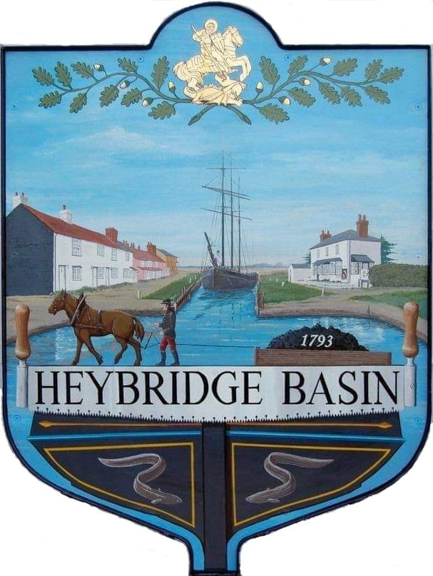

HEYBRIDGE BASIN PARISH COUNCIL

Minutes of the Extraordinary meeting of Heybridge Basin Parish Council held on Tuesday 20th August 2024 at 06:30pm, at The Lock Tearoom.

PRESENT

In the Chair: M. Hodges (Chair) Absent: 0

Councillors: R. Bryson (Vice Chair) Apologies: 3
J. Sjollema
M. Hobden Public: 7

Officers: G. Lake – Clerk District Cllrs: 0

It was noted that this meeting was being recorded by the Clerk.

24/059 Chair’s Welcome.
The Chair opened the meeting and explained that the Extraordinary meeting was called due to some matters requiring discussion prior to the next scheduled full council meeting.

24/060 To note apologies for absence.
Cllrs Swann, Howat and Edmond.

24/061 To receive Declarations of Interest in accordance with the Council’s Code of Conduct and with section 106 of the Local Government Finance Act 1992.
Cllr Hobden – Non-Pecuniary – HBSA, Basin Oars and HB River care and Cllr Bryson – Non-Pecuniary – Family member part of the Basin Oars.

24/062 Finance.
- To approve
- Payment requests for July/August 2024
The Payment requests as previously circulated were approved.
- Receipts for July/August 2024
The receipts as previously circulated were approved.

24/063 Planning Applications
- To consider any planning applications received after the publication of the agenda and to agree the action to be taken.

24/00570/TCA– Boat Building Yard, Lock Hill – T1 Norway maple – Fell. T2 Hawthorn x2 – Fell. T3 Hawthorn x2 – Fell. T4 to T6 & T14 Elder – Fell. T7, T9, T11, G12 – Goat Willow – Fell. T8 White willow – Fell. T10 Silver birch – Fell. T13 Tree of heaven – Fell. T15 Blackthorn – Fell.
It was resolved for the Council to recommend the refusal of permission to fell the trees in support of the response from The Conservation Society, no reason was given within the application, and that it was not in the best interest for the wildlife. It was resolved to request TPO’s should the Council have the power to do so.

24/064 Daisy Meadow Car Park (DMCP)
  - To review and discuss the report from Haydn Evans and agree any action to be taken.
The Haydn Evans report had been received and previously circulated. It was resolved to accept the report and sign off the works to the Access Road and send a copy to Camway.

24/065 Village Sign
- To receive an update from the Clerk and agree any action to be taken.
The Clerk informed members that the damaged village sign was neither the responsibility of Highways nor MDC, but of the Parish Council. The sign is within the boundary of Heybridge Parish Council who were happy to pass to HBPC to deal with. The white village gates are due to be installed in October. It was resolved to defer this item until the gates were installed.

24/066 Donation Request
- To consider the request from The Basin Oars and agree any action to be taken.
The Basin Oars requested £50.00 towards the cost of the Portaloos for their event on Saturday 14th September 2024.

2 members of the Council had a non-pecuniary interest in The Basin Oars. As only 2 members were able to cast a vote, the Council was not quorate and was unable to vote on this matter.

The Chair approved to use the Chair’s Allowance to donate the £50.00

24/067 Pursuant to section 1(2) of the Public Bodies (Admission to Meetings) Act 1960 it is resolved that, in view of the confidential nature of the business about to be transacted, it is advisable in the public interest that the press and the public be excluded, and they are instructed to withdraw.

All members of the public left.

24/068 Goal Posts and Netball Hoop
- To review the draft licence agreement from Maldon District Council and agree any action to be taken.
The draft licence agreement had previously been circulated. It was resolved for the Clerk to challenge the fee, and clauses 3.2 and 3.17 as well as request permission to alter the orientation of the goal posts and netball hoop.

There being no further business the meeting closed at 07:04pm
Provisional Date of the next Council Meeting Tuesday 10th September 2024

Clerk Contact details: clerk@heybridgebasinpc.org.uk
Website: www.heybridgebasin-pc.gov.uk

